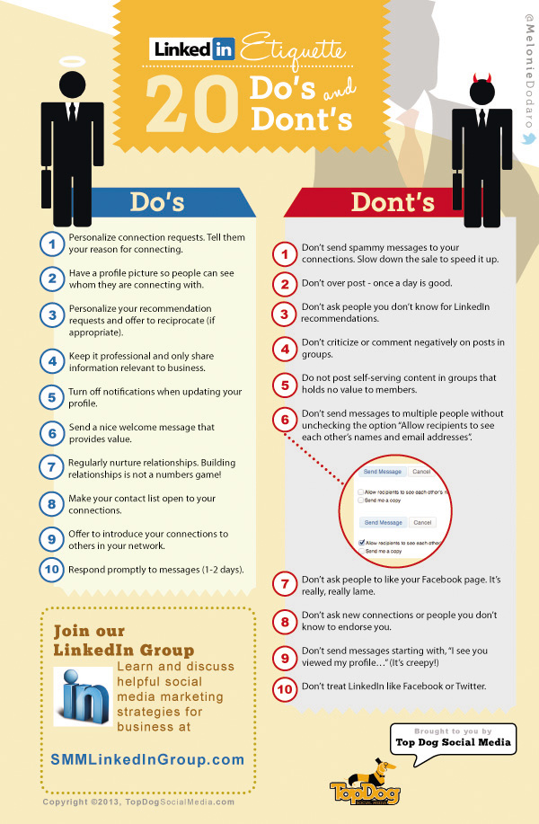
(http://theundercoverrecruiter.com/wp-content/uploads/2013/09/LinkedIn-Etiquette.jpg)
Retrieved from the internet on 10/12/13 at 6:23 pm

