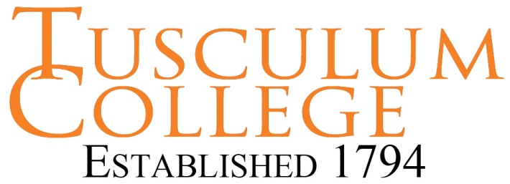
DRESS FOR SUCCESS – MEN
Men’s Business Professional –Interview Clothing

- Wear a conservative, dark suit in solid colors or subtle pin-stripe in black, brown, navy or grey

- Keep jackets buttoned when standing, unbuttoned when seated; so avoid double-breasted jackets

- Check fit: sleeve hem should fall ½ inch below wrist and shirt hem should fall ½ inch below jacket hem

- Wear suit pants that match in color and fabric

- Check fit: pant hem should have a slight crease in front and reach the top of the shoe and top of heel in back.

- Wear a conservative tie in pattern and color

- Tie length should just reach your belt

- Wear a white or light blue long sleeve, collared shirt

- Press shirt with starch or dry clean

- Check fit: shirt sleeve hem should extend ½ inch beyond jacket sleeve hem

- Polished leather conservative style shoes in black or brown

- Wear dark, calf-length, socks that match shoes in black or brown

- Wear a belt matched to shoe color

- Earrings may not appeal to conservative recruiters

- Wear minimal or no jewelry other than a conservative watch

- Fresh haircut is recommended, long hair may present a barrier to hire for some employers, facial hair should be neatly groomed, clean-shaven is best.

Prepare For the Interview

- Dry clean suit one week prior, unpack and press clothing the night before the interview

- Remove lint, dangling threads, and tacking stitches found in new suits

- Bring a portfolio to house resumes, business cards, pen and notepad, don’t bring a backpack to interviews

- Cover tattoos and piercings with clothing, other than ears.

- Make sure all clothing is clean, pressed, hemmed and fits appropriately

- Avoid strong after-shave or cologne

