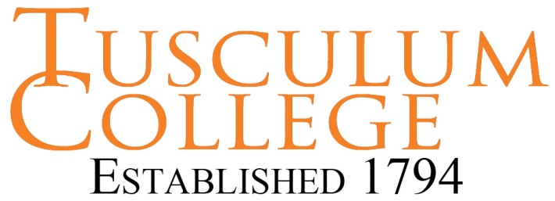
Successful Interviewing

Before the Interview:

- Know yourself and your goals. Prepare to communicate your skills, talents, interests, and achievements, as well as, how your skill set meets the employers need (job requirements). The interviewer will be assessing not only the content of what you say, but how you communicate the information.

- Know the employer. Research the culture, financial stability, product/service, size and reputation of the company, before the interview. Informational interviews with a trusted colleague, employed in this company or industry can provide valuable information. Good research will help you to communicate how you are a good fit for the position.

- Expect tough questions from your interviewers. Prepare and rehearse your answers. You can easily find good interview questions online. Do not try to memorize the answers. Just rehearse answering potential questions from interviewers. Mock Interviews can be very helpful in this preparation. Additionally, interviewers will assess your ability to handle the stress of the job interview, in order to, determine your ability to handle stress on the job.

- Dress appropriately for the interview. First impressions affect your chances of communicating effectively. A well-groomed, conservative appearance, consistent with the work environment, demonstrates your compatibility with the company. Work interviews require more formal attire than is usually worn on a daily basis in the workplace. Business attire is expected in the interview, even when, business casual is the common dress code for everyday.

- Arrive early for the interview. You will demonstrate your interest and professionalism. Greet your interviewer with good eye contact, smile and a firm, warm handshake saying, “It’s nice to meet you.”

During the interview:

- Be genuine. Be your best professional self. You want to ensure a good fit for you and the employer.

- Be positive, even about seemingly insignificant items. If something negative comes up, be factual and do not offer excuses. You might even mention something positive that you learned from the experience. This demonstrates maturity and a teachable attitude.

- Listen well. Your ability to answer the interviewer’s questions effectively depends on your ability to hear the question. You must be prepared to answer any issues raised in your interview.

- Speak clearly and make good eye contact with all your interviewers. The interviewer will assess your composure, confidence, and body language. Monitor your energy level. It speaks volumes about you. If you have low energy in the interview, interviewers may question your interest and ability to produce. If your energy in the interview is too high, interviewers may have concerns about your interpersonal effectiveness. Congruency in all these areas strengthens your oral communication.

- Clearly describe how your skills, abilities and interests fit with the job requirements of the employer. Spell this out for the employer with specific illustrations from past work accomplishments. A little enthusiasm can be productive when describing past successes. It demonstrates your enjoyment of the work.

- Ask good questions of the interviewer. You can research internet listings, starting with the website of the organization, which you are interviewing. Other career search resources are listed on the Tusculum Career Services website. Your questions demonstrate your interest, skill, and enthusiasm for the job. Allow the interviewer to initiate any discussion about salary and benefits.

- Remember proper etiquette in the interview. Interviewers will assess your professional presentation in all aspects. Employers want to be sure that you will present a professional image for their company. They also want to be sure that you will fit into the company culture.

After the Interview:

- Follow up with a thank you note to each person who interviewed you. This is a professional rule of conduct for all interviews. Handwritten notes are best. Use the thank you note to describe why you think you would be a good fit for the job, mentioning a related question or comment of the interviewer. This also demonstrates your continued interest and enthusiasm for the job.

