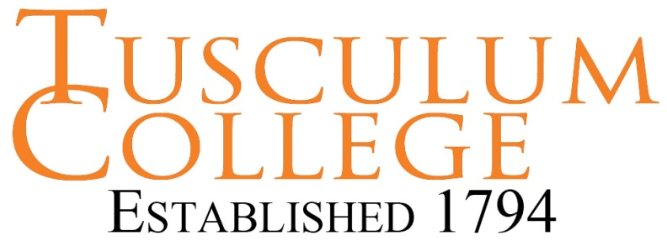
Resume Tips
- Resumes should communicate how the applicant’s skills, abilities and interests match a specific employer’s job requirements for a specific position.

- Be concise, you have 15 seconds or less to gain the attention of the employer. Focus on strengths and positive images. Use bullets (dashes, if an e-resume) to highlight achievements. Use the appropriate amount of detail.

- Be honest and genuine. Provide relevant examples of accomplishments. Never lie or misrepresent your abilities on a resume.

- Utilize action verbs to initiate statements; omit pronouns.

- Include relevant keywords from job description to meet online resume screening requirements for interview selection. Repeat keywords and spell out acronyms, degrees, and titles to increase keyword hits and ranking. Be relevant; only applicable keywords improve your odds.

- Proof resume for typos, spelling, consistency and grammar.

- Review resume for overall theme. Tell one story about your work. Include only relevant information.

- Limit work experience to the last 15 years, in most cases.

- Avoid visual clutter and photos. (Some employers like photos others discard resumes, which have photos.)

- Avoid passive or negative statements or tone. Avoid obscure terminology and slang.

- Include a cover letter, which briefly explains any gaps in employment or additional relevant information not included on the resume. Use keywords in the cover letter to improve interview selection odds.

- Consider whether your resume should be chronological or functional. More information about chronological or functional resumes can be found in the resume builder feature on your home page of College Central Network.

- It is helpful to utilize an online resume builder from an online source, such as College Central Network. However, resume templates and pdf files can hide resume keywords from employer screening software. Therefore, it is best to print resumes constructed with online templates; then, re-type the information into a blank Word document for use in online applications.

- Resume length should be an appropriate length to match the amount of work experience. One page resumes are usually appropriate for traditional students, who may not have many years of work experience. Non-traditional students with many years of work, require a longer resume.

Create a student or alumni account on College Central Network at www.college central.com/tusculum to find more online resources about creating winning resumes.

