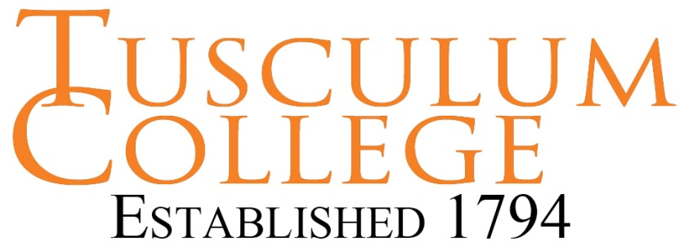
Interviewing Tips

Different Types of Interviews

Basic Clarification: Employers want greater understanding of education, experience and accomplishments listed on the resume. They also want to know your expectations of the employer and career goals.

Behavioral: Employers want to know specific examples of how you overcame obstacles and achieved successes in situations similar to the job, for which you are interviewing.

Case Analysis: Employers may test the skills you claim on your resume to ascertain your level of proficiency. They want to know if you can comprehend a complex set of facts, create a framework to analyze them, and develop a logical and useful conclusion.

Group Interviews: Employers may want to test maturity, self-marketing abilities, leadership and team orientation. This type of interview may be used in an online screening interview or an on-site interview. It may require interactive exercises, presentations, meal or reception.

Three Common Interviewing Mistakes

1. Not researching the company: Check the company website, check Google for recent news developments related to the company or industry, and check other online resources, such as, Glassdoor, AfterCollege, Vault and others. For more information, check Tusculum Career Services Resources page.

2. Not having clear goals: Know your short-term and a long-term career goals. Focus on the short-term goal related to the specific job, for which you are interviewing. However, be prepared to articulate how your long-term goal relates to your short-term goal.

3. Not having business/industry-related answers: When an interviewer asks you to give an example of a relevant skill for the job, do not use an illustration from a social setting, classroom assignment or sports; unless, you can effectively explain how that skill transfers into the business setting. This is difficult to accomplish. Therefore, it is best to use only examples from previous work settings, internships, or volunteer work.

Interviewing Tips

- Employers are viewing you from a different perspective. They want to know how potential clients, coworkers and supervisors will perceive your ability and professional conduct.

- Do not be afraid to ask the interviewer to clarify a comment or question in the interview. You have to understand what the interviewer is saying, in order to respond intelligently.

- Take paper and pen for note taking. You can purchase an inexpensive portfolio to keep the pen and paper folded away until needed.

- Take a list of prepared questions for the interviewer. You can also take notes during the interview for additional follow up questions.

- Take a moment to think about your answers, as needed. Interviewers appreciate a well-considered answer versus a rushed response that might be less effective.

- Provide appropriate detail in your answers. The STAR method is helpful: (Situation, Task, Action, and Result). Don’t give too much detail. If the interviewer’s eyes begin to glaze over, you may be giving too much detail.

- Look over sample interview questions in advance and practice your answers with a friend or career coach. It might be helpful to practice aloud in front of your mirror at home.

- Always be professional. Even when you know your interviewer through other settings, it is best to be professional in the interview. This includes writing thank you notes for each interviewer you meet.

